LLM Inference
Ref: https://handbook.modular.com/

Calculate GPU memory needed for serving LLMs:
Memory (GB) = P * (Q / 8) * ( 1 + Overhead )
P – Parameters in Billions (Billions = Giga = 10^9)
Q – Bit Precision ( quantization ) (FP32 = 4 Bytes = 4 * 8 Bits)
Overhead - Typical range: 10–30%. Covers KV cache, activations, and framework buffers.
Eg:
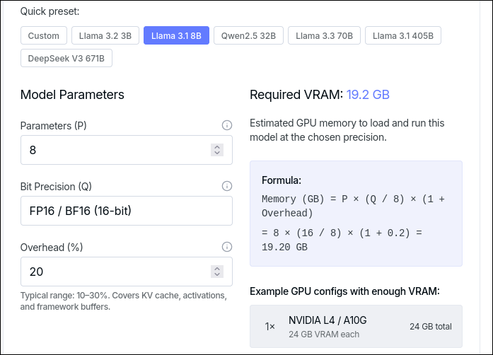

KV Cache Memory Calculation:
KV Cache size (GB) = 2 * B * N * L * model_dim * (Q/8) / (1024 ^ 3)
B – No. of Batches
N – Sequence Length (No. of tokens in the sequence)
L – No. of layers Self-Attention
model_dim – H * D (# attention heads * Head_Dimension) – Embedding size
Eg:
